Chart Widgets.

Legal.
The chart widgets are a wrapper around Chart.js:
http://www.chartjs.org/
Chart.js is open source and available under the MIT license:
https://opensource.org/licenses/MIT
Permission is hereby granted, free of charge, to any person obtaining a copy of this software and associated documentation files (the "Software"), to deal in the Software without restriction, including without limitation the rights to use, copy, modify, merge, publish, distribute, sublicense, and/or sell copies of the Software, and to permit persons to whom the Software is furnished to do so, subject to the following conditions:
The above copyright notice and this permission notice shall be included in all copies or substantial portions of the Software.
THE SOFTWARE IS PROVIDED "AS IS", WITHOUT WARRANTY OF ANY KIND, EXPRESS OR IMPLIED, INCLUDING BUT NOT LIMITED TO THE WARRANTIES OF MERCHANTABILITY, FITNESS FOR A PARTICULAR PURPOSE AND NONINFRINGEMENT. IN NO EVENT SHALL THE AUTHORS OR COPYRIGHT HOLDERS BE LIABLE FOR ANY CLAIM, DAMAGES OR OTHER LIABILITY, WHETHER IN AN ACTION OF CONTRACT, TORT OR OTHERWISE, ARISING FROM, OUT OF OR IN CONNECTION WITH THE SOFTWARE OR THE USE OR OTHER DEALINGS IN THE SOFTWARE.

Package contents

Name | Type | Description
DF_DECDTA | Field | Decimal to pass the chart data
DF_ALPHAO | Field | Decimal to pass color opacity
DF_T71O_BarChart | Widget | JavaScript wrapper around Chart.js. Draws a bar chart
DF_T71O_PieChart | Widget | JavaScript wrapper around Chart.js. Draws a pie, doughnut and polar area chart
DF_T71O_BarChart_Access | Reusable Part | A layer between the BAR widget and the web panel to facilitate default settings and minimize the code written in the Handler or top layer.  The widget definition is in this component.
DF_T71O_PieChart_Access | Reusable Part | A layer between the PIE widget and the web panel to facilitate default settings and minimize the code written in the Handler or top layer.  The widget definition is in this component.
VL_BarChart_Handler | Web Page | The top layer. For basic BAR charts this is the only component you would need to change.
VL_PieChart_Handler | Web Page | The top layer. For basic PIE charts this is the only component you would need to change.
Chart.js | External Resource | https://cdnjs.cloudflare.com/ajax/libs/Chart.js/2.5.0/Chart.js

Install Package
1. Extract ChartPackage.zip, for example into <lansa root>\x_win95\x_lansa\x_dem\QuickExport
2. Start the IDE and import from folder used in the first step.
It is recommended to Save as Repository list.
3. Compile everything.

How does it work
The examples are structured in three layers: Handler (web page) Access Widget

Handler – top layer
The handler is where you provide the data and set the attributes of the chart.
1. Define the Access reusable part, for example for a Bar chart:
Define_Com Class(#DF_T71O_BarChart_Access) Name(#BarChart) Parent(#COM_OWNER)

2. Listen to uChartInitialized before using the widget. For example:
Evtroutine Handling(#BarChart.uChartInitialized)

3. Populate the chart using the methods in DF_T71O_BarChart_Access or DF_T71O_PieChart_Access reusable parts.
Executing VL_PieChart_Handler should produce this chart:
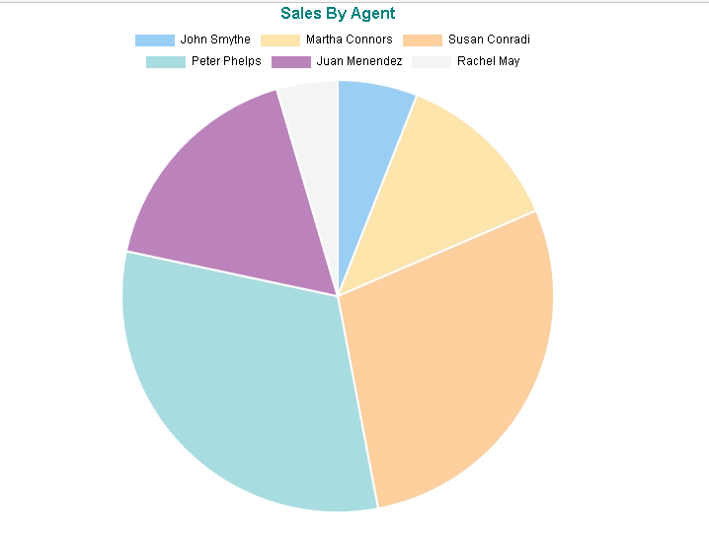

You can click on agents and the PIE will filter out that data:
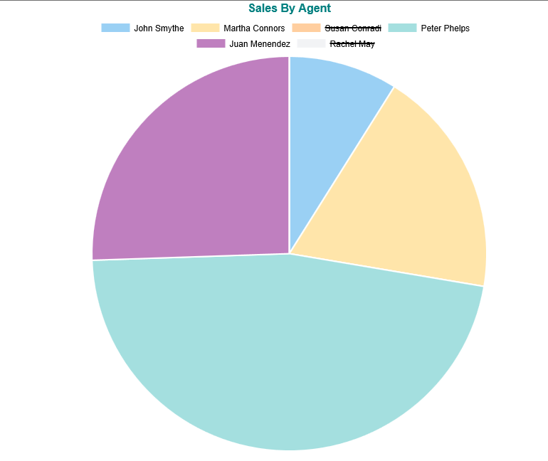

Executing VL_BarChart_Handler should produce this chart:
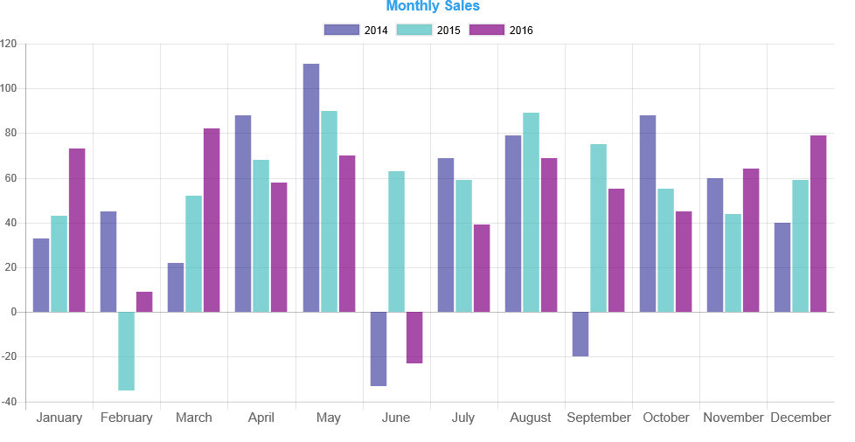
Again, you can filter data if you click on the legend, don’t show 2014:
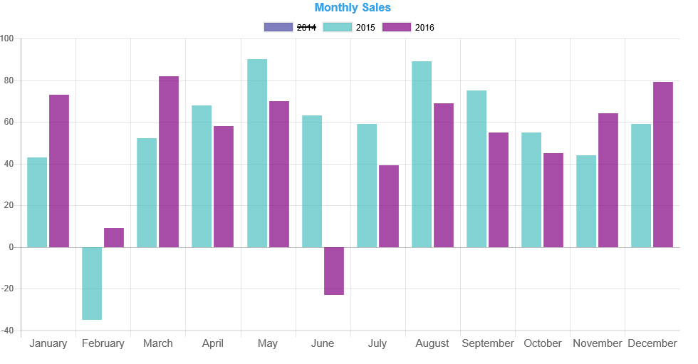

Access – middle layer
The chart uses its own default values for fonts, colors, positioning and many other attributes.
The middle layer allows you to standardize them. Applications using this component will need less code.
All methods have a Mandatory parameter.
If you modify the appropriate Mandatory value to the one mostly or only used by your application, the handler will not need to specify it.
Example: In the above, when setting the title the background color is set to black.
If you wanted all your titles in black, you locate the uShowTitle method and change the Mandatory parameter value from “” to “black”.
Define_Map For(*INPUT) Class(#PRIM_ALPH) Name(#FontColor) Mandatory("black")
Another example: Negative values are shown in red background across my application.
You could add logic to uAddBar so that if the data is negative, the background is set to red and none of the handlers will have to specify it.

Widget – bottom layer
The wrapper around Chart.js.
You shouldn’t change this code unless:
1. You have JavaScript knowledge.
2. You are familiar with the Chart.js documentation.

Setting Colors
Colors can be passed in two string formats:
RGB, this is the recommended way: a string of RGB values separated by commas, for example:
#PieChart.uAddPieSection Data(10) Label("John Smythe") Backgroundcolor("204,0,204")
Name: the color name as defined in the widget’s chartColors object.
If you don’t understand what it means, stick to the RGB.
this.chartColors = {
red : "rgb(255,99,132)",
orange : "rgb(255,159,64)",
yellow : "rgb(255,205,86)",
green : "rgb(75,192,192)",
blue : "rgb(54,162,235)",
purple : "rgb(153,102,255)",
cyan : "rgb(0,255,255)",
magenta: "rgb(255,0,255)",
purple : "rgb(128,0,128)",
teal : "rgb(0,128,128)",
navy : "rgb(0,0,128)",
black : "rgb(0,0,0)",
grey : "rgb(231, 233, 237)"
};

