Web Configuration Troubleshooting PC Only

Basics to check first.
- You have a Valid Web License
- The Listener is started
- IIS is running.
- Your IIS is pointing to the correct plugin.

Web Admin Console.
- Open Web Admin Console. Go to File > Local Configuration and Select Open Active
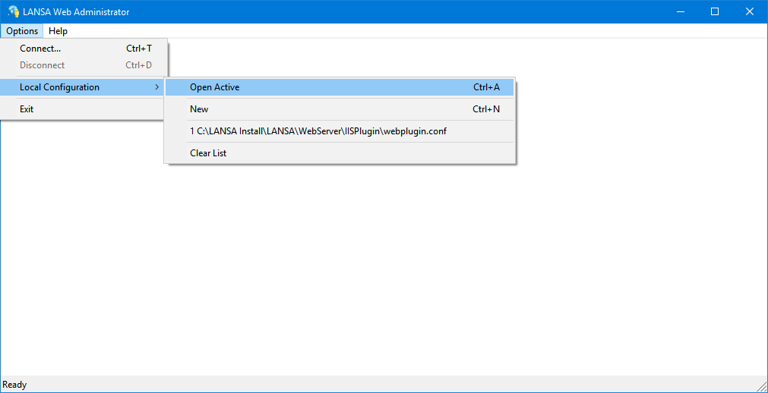
If this does not open, check that the webplugin.conf file (lansaweb.cfg pre V14) exists in the IISPlugin directory e.g. C:\Program Files (x86)\Lansa\WebServer\IISPlugin\Webplugin.conf
If this does not exist Create new and put this there and save it to the IISPlugin directory
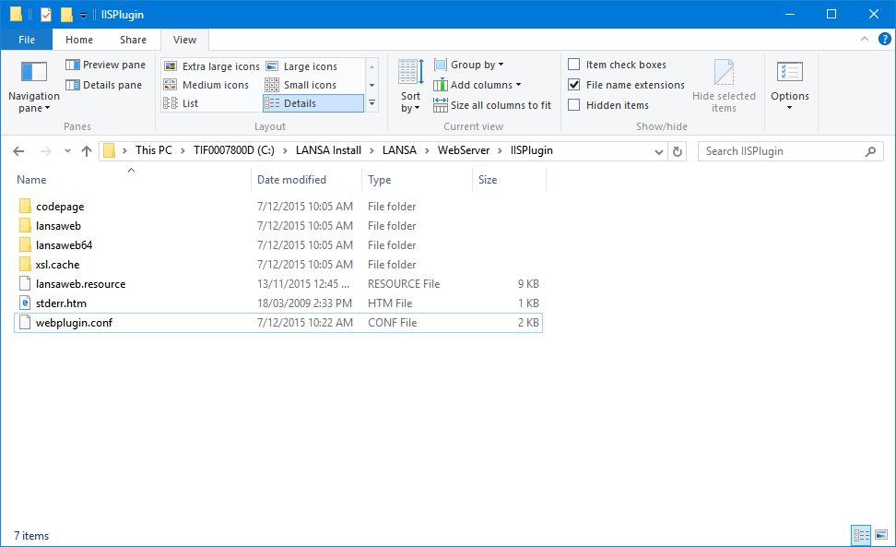
- Once you have the configuration file open in the Web Admin Console go to Tools > Maintain LANSA Systems
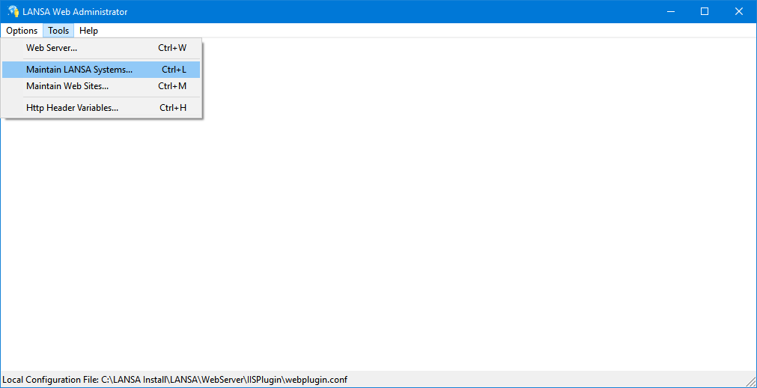
- Double Click on the Target System or Press the change button when selected.
If one does not exist create one by selecting Add.
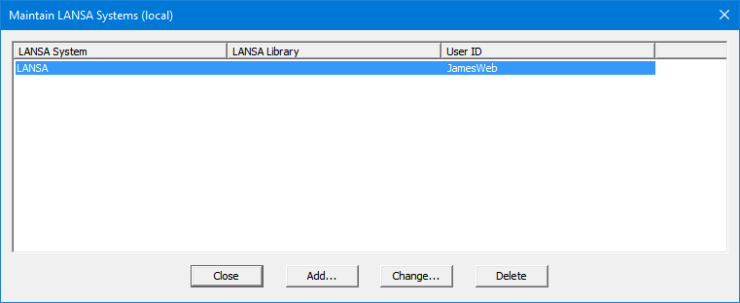
- When in the LANSA System setting click the ellipse on the Right of the LANSA System Field
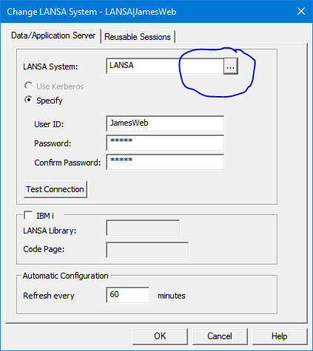
- This will open the LANSA Communications Table.
Make sure the listener that used by you system is correct aswell as the TCPHost referenced. To avoid confusion, running Localhost maybe easiest.
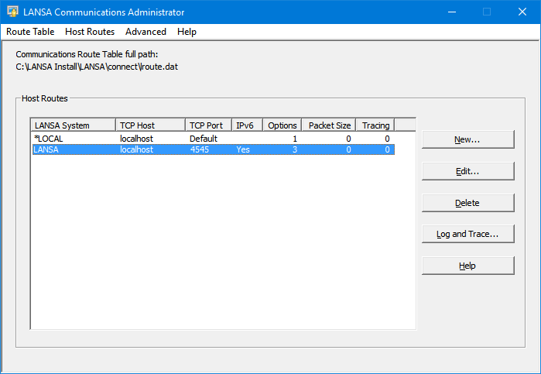
- Close the communications table to go back to the LANSA System setting. And press Test Connection.
If the connection does not succeed a few common reasons are
(0x00000014) = The listener is not active or cannot be found - check your listener and system name are correct
(0x00000006) = Wrong Username and/or Password – check you used the right credentials
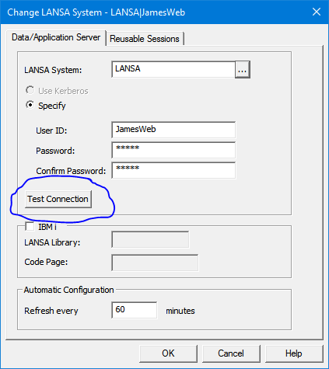
- Once this has passed, go back to the main Web Administrator View and Select Tools > Maintain Websites.
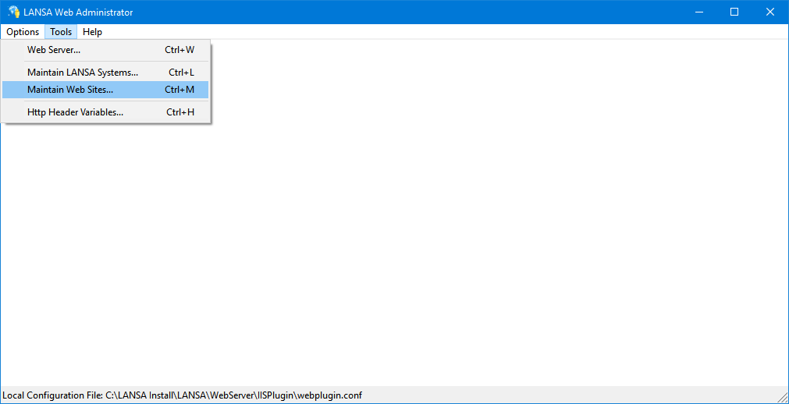
- Open your website configuration by double clicking on it or selecting change
If one does not exist select add.
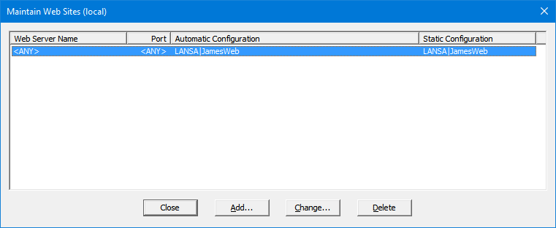
- In this, if you are using the ANY ANY setting, leave it as is. Otherwise check the Name and Port are correct, the port will be the binding set in IIS.
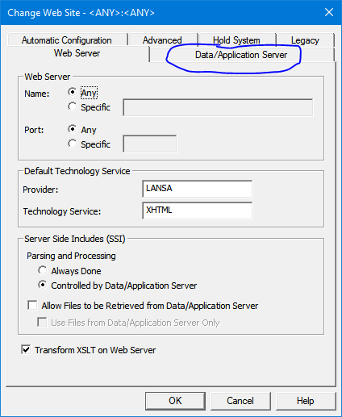
- Now go to the Data/Application Server Tab
This should coincide with the one that was check in steps 2 through 7
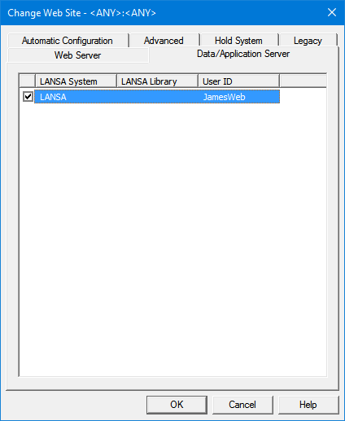
- Now save and Close your Local Configuration file. If any chances were made the IIS must be reset for them to apply.
- Now go to Option > Connect
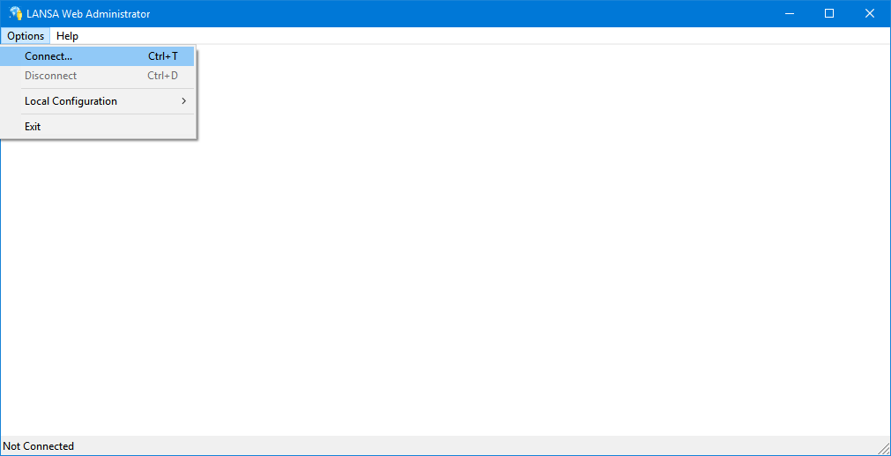
- Now Sign into the LANSA System Details.
If the connection does not succeed a few common reasons are:
User does not have permissions to the use Web Administrator - Try using PCXUSER or making the webusers group PCXUSER
Error Code
(0x00000014) = The listener is not active or cannot be found - check your listener and system name are correct
(0x00000006) = Wrong Username and/or Password – check you used the right credentials
(0x00000011) = No permissions to the Database. Check the user exists in Both Windows and in LANSA, and share a common Password, then check that the Windows user has permissions to the Database.
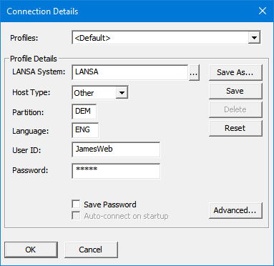
- Once Connected go to Security > User Registration
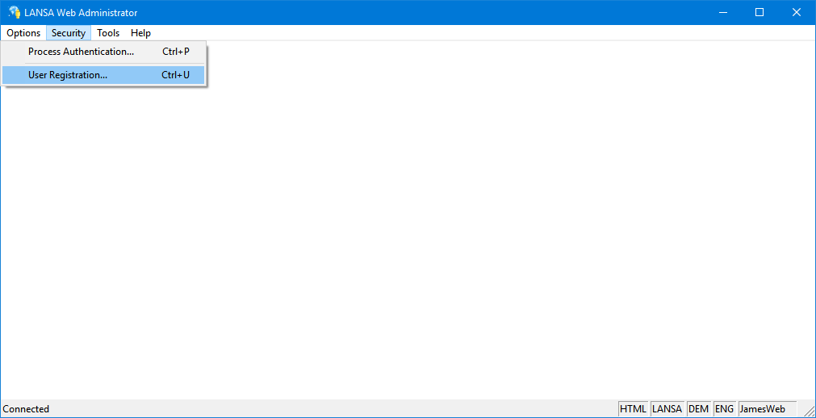

- Make sure the web user profile is allowed to use the Web server.
If no user is added select add.
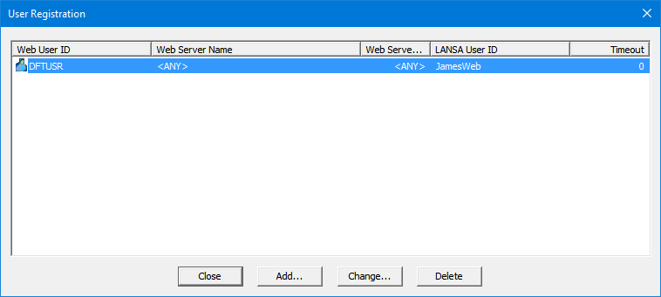
- Double Click the User profile or select change and enter the password when prompted to open the settings for the user profile.
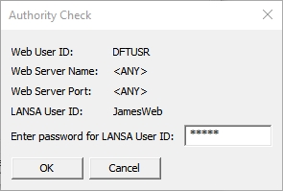
- In this window Make sure the settings match the website and the click Test.
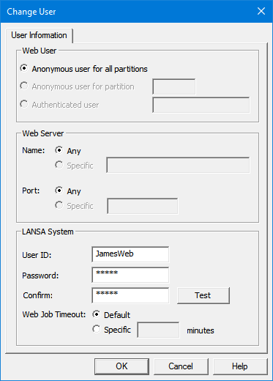
- If this passes close down the web administrator console and try running the following url.
http://localhost/lansaweb/lansaweb?about
If this fails after completing all the steps contact support.
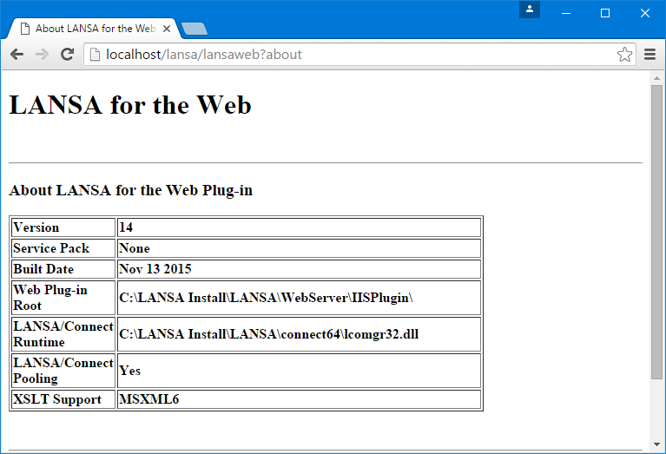
- Next test http://localhost/cgi-bin/lansaweb?about
If this fails after completing all the steps contact support.
If both succeed your LANSA Web configuration should be ready to use.

